Installation Guide to consider source code check-in and check-out from SVN repository

Installing TortoiseSVN

System requirements
TortoiseSVN runs on Windows Vista or higher and is available in both 32-bit and 64-bit flavours. The installer for 64-bit Windows also includes the 32-bit extension parts. Which means you don't need to install the 32-bit version separately to get the TortoiseSVN context menu and overlays in 32-bit applications.
Support for Windows 98, Windows ME and Windows NT4 was dropped in version 1.2.0, and Windows 2000 and XP up to SP2 support was dropped in 1.7.0. Support for Windows XP with SP3 was dropped in 1.9.0. You can still download and install older versions if you need them.

Installation
TortoiseSVN comes with an easy to use installer. Double click on the installer file and follow the instructions. The installer will take care of the rest. Don't forget to reboot after installation.
(Or)
Installation guide for svn:
http://o7planning.org/en/10261/installing-and-using-tortoise-svn

How to check-out source code into your repository:
Create the folder where you want to have your project files. Then right click on it and select TortoiseSVN → Checkout…. Enter the URL to checkout, in this case https://coconet-svn-in-01.capgemini.com/svn/repos/dcxeyewear and click on OK (shown in Figure1). The files are then downloaded to the folder (Figure2).
In order to be able to check in, fill in your username and password.
Figure 1
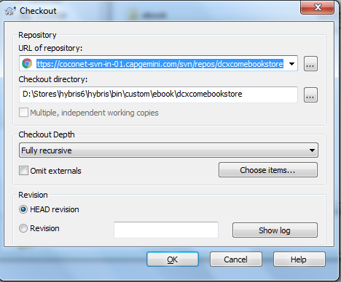

The Repository folder structure looks like below:

Figure 2
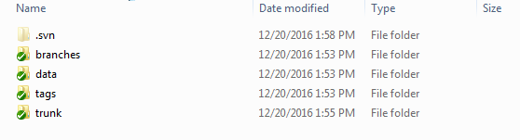
The trunk folder structure looks like below
Figure 3
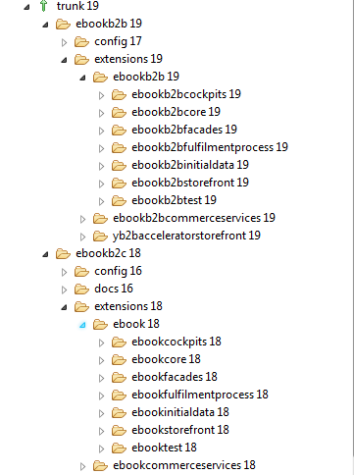

How to check-in source code into your repository:
There are several ways to check-in the source code into your repository.
- Using repo browser:
- Right click on trunk folder and select TortoiseSVN→Repo-Browser
- Adding the projects as defined in figure3, we need to check-in into your repository.
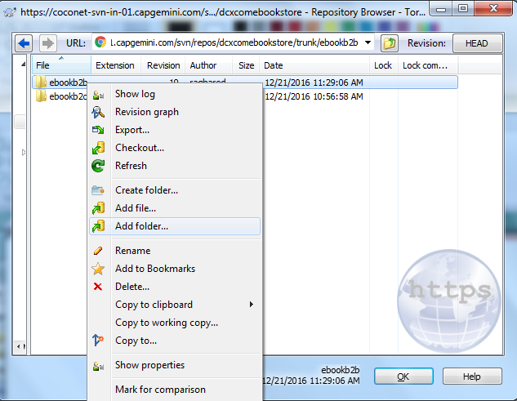

- Another way is to adding projects into repository:
Directly go to hybris directory and select which project need to import by using, Right click on folder→TortoiseSVN->import
For example: adding config folder

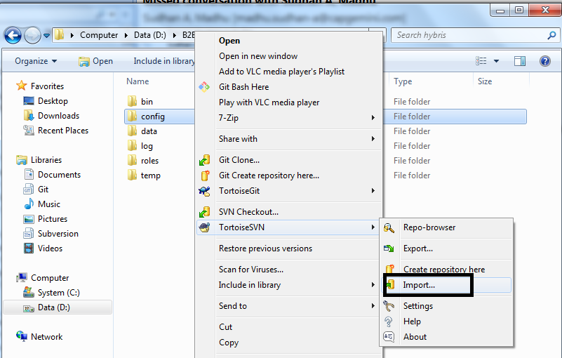
- Give full URL of repository and give import message and then ok.
https://coconet-svn-in-01.capgemini.com/svn/repos/dcxeyewear/trunk/eeyewearB2B/config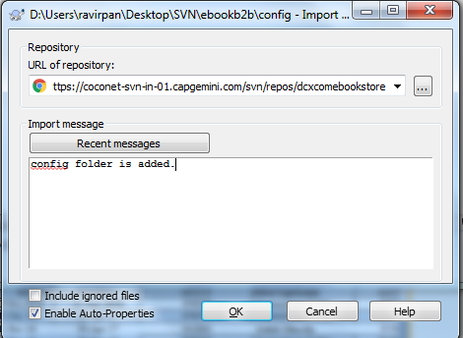

Committing Changes to the Repository:
A commit will enter your changes into the repository. Changes will only be entered into the repository when you commit, this includes adding and deleting files.
Right click within the folder and select SVN Commit...
- Enter notes in the Message section to describe the changes that are being checked in. You can also select which modified files should be committed.

